**1.Limitation of Service(-,-) method:-**

* In service(-,-) method of servlet component, we can’t differentiate the request processing logic for doGet(-,-) method and doPost(-,-) method.
* The servlet API provided two service(-,-) methods.

Public service(ServletRequest, ServletResponse)

Protected service(HttpServletRequest,HttpServletResponse).

* + These methods creates confusion to programmer.
* The public service(-,-) method receives only ServletRequest class object and ServletResponse object as arguments. Therefore , Getting the Http protocol features in this method is not possible.

To over come above problems, Use doXXX(-,-) methods.

2. doGet(-,-) and doPost(-,-)methods:-

Usually, Browser generates only Get,Post mode requests.

How to use

Approach:1 If both GET and POST methods wants to execute same request processing logic then

1. Override doGet(-,-) and doPost(-,-) methods in servlet component.
2. Place request processing logic in user defined method.
3. Invoke the user-defined method in the body of doGet(-,-) and doPost(-,-) method.

Example:-

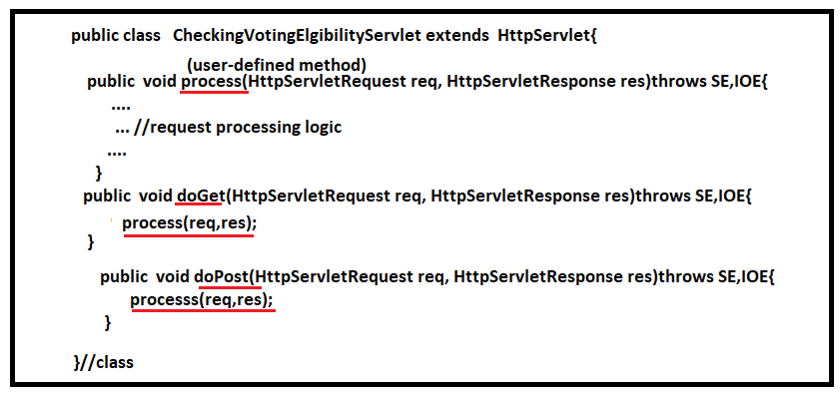

Approach:2 If Both Get and Post mode request wants to execute the different processing logic, then

1. Override the doGet(-,-) method and doPost(-,-) method.
2. Place Get mode request processing logic in doGet(-,-) method.
3. Place Post mode request processing logic in doPost(-,-) method.

Example:-

